**Resources**

[Install ESP866 in arduino IDE](https://arduino.esp8266.com/stable/package_esp8266com_index.json)

[All source codes](https://github.com/PatrickNiyogitare28/embedded_iot_practice.git)

<https://github.com/fdebrabander/Arduino-LiquidCrystal-I2C-library.git>

**Tools**

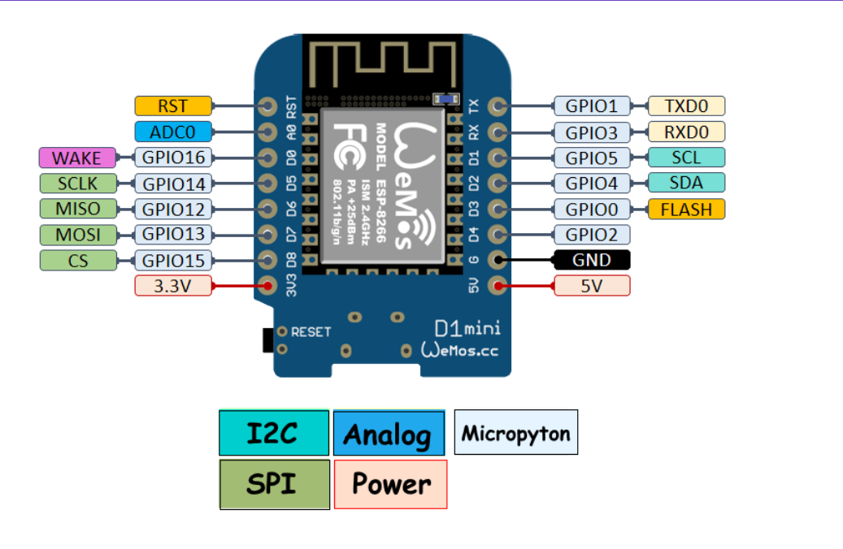

* **Utra sonic sensor**
* **LCD(Liquid Crystal Display.)**

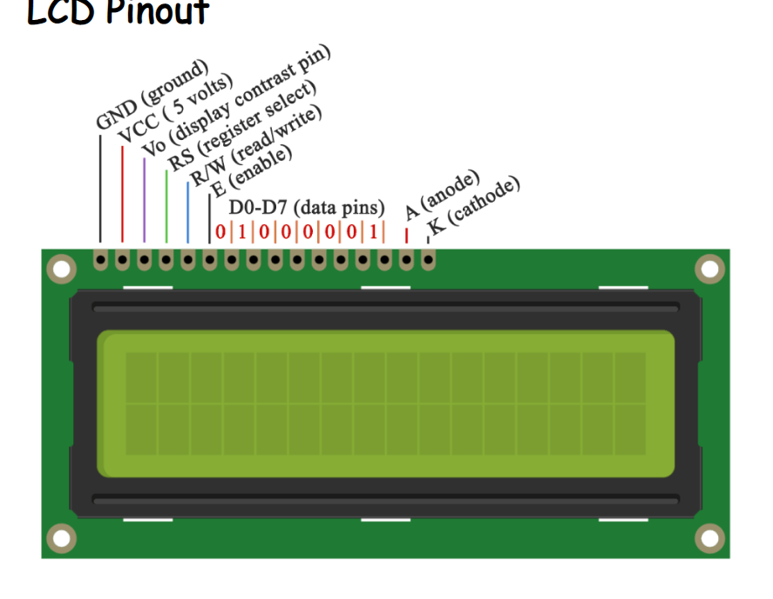

**Temperatur sensor**

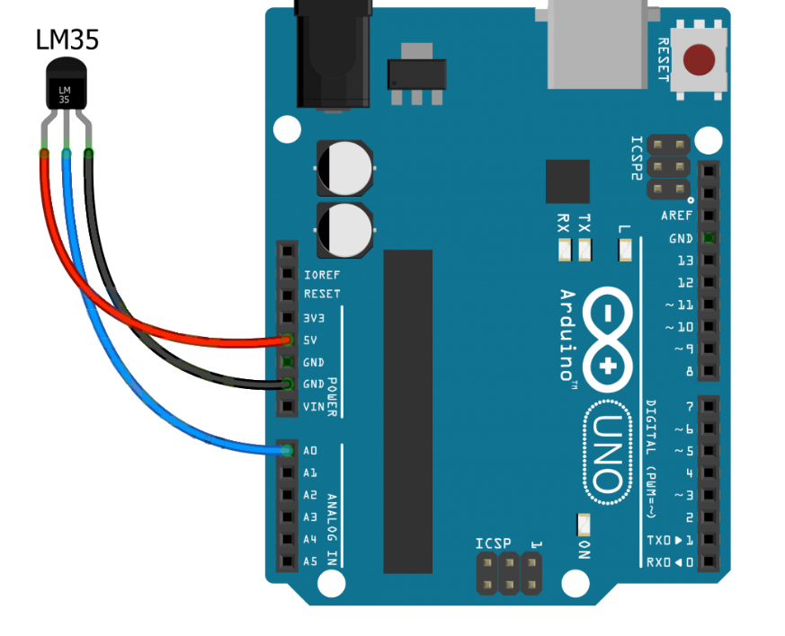

**LCD code**

**#include<Wire.h>**

**#include<LiquidCrystal_I2C.h>**

**LiquidCrystal_I2C lcd(0x27, 16 , 2) ;**

***void* setup(){**

**lcd.begin();**

**lcd.backlight();**

**lcd.print("hello");**

**}**

**// the loop function runs over and over again forever**

***void* loop(){**

**//lcd.clear();**

**//lcd.print("hello");**

**//delay(500);**

**//lcd.clear();**

**}**

**distance_sensor**

**Download LiquidCrystal_I2C.h k**

**#include<Wire.h>**

**#include<LiquidCrystal_I2C.h>**

***int* redPin = 13;**

***int* greenPin = 12;//GPIO 13 corresponds to pin D7. You can check the pinout.**

**const *int* trigPin = 14;**

**const *int* echoPin = 16;**

***long* duration, distance;**

**LiquidCrystal_I2C lcd(0x27, 16, 2);**

***void* setup(){**

**lcd.begin();**

**lcd.backlight();**

**// initialize ledPin as an output.**

**Serial.begin(9600);**

**pinMode(redPin, OUTPUT);**

**pinMode(greenPin, OUTPUT);**

**pinMode(trigPin, OUTPUT);**

**pinMode(echoPin, INPUT);**

**}**

**// the loop function runs over and over again forever**

***void* loop(){**

**digitalWrite(trigPin, LOW);**

**delayMicroseconds(2);**

**digitalWrite(trigPin, HIGH);**

**delayMicroseconds(10);**

**digitalWrite(trigPin, LOW);**

**duration = pulseIn(echoPin, HIGH);**

**distance = (duration / 2) / 29.1;**

**if (distance >= 100 || distance <= 0){**

**digitalWrite(greenPin,HIGH);**

**digitalWrite(redPin,LOW);**

**Serial.println("Out of range");**

**lcd.print(distance);**

**}**

**else {**

**digitalWrite(greenPin,LOW);**

**digitalWrite(redPin,HIGH);**

**Serial.print(distance);**

**Serial.println(" cm");**

**}**

**delay(500);**

**}**

**Wifi**

**distance_seinsor_wifi(send data)**

**#include<Wire.h>**

**#include<LiquidCrystal_I2C.h>**

**#include <ESP8266WiFi.h>**

**WiFiClient wifiClient;**

***int* redPin = 13;**

***int* greenPin = 12;//GPIO 13 corresponds to pin D7. You can check the pinout.**

**const *int* trigPin = 14;**

**const *int* echoPin = 16;**

***long* duration, distance;**

**LiquidCrystal_I2C lcd(0x27, 16, 2);**

***void* setup(){**

**WiFi.begin("RCA-WiFi", "rca@2019");**

**lcd.begin();**

**lcd.backlight();**

**// initialize ledPin as an output.**

**Serial.begin(9600);**

**pinMode(redPin, OUTPUT);**

**pinMode(greenPin, OUTPUT);**

**pinMode(trigPin, OUTPUT);**

**pinMode(echoPin, INPUT);**

**}**

**// the loop function runs over and over again forever**

***void* loop(){**

**String host = "192.168.1.68";**

**String path = "/iot/";**

***int* port = 8000;**

**digitalWrite(trigPin, LOW);**

**delayMicroseconds(2);**

**digitalWrite(trigPin, HIGH);**

**delayMicroseconds(10);**

**digitalWrite(trigPin, LOW);**

**duration = pulseIn(echoPin, HIGH);**

**distance = (duration / 2) / 29.1;**

**if (distance >= 100 || distance <= 0){**

**digitalWrite(greenPin,HIGH);**

**digitalWrite(redPin,LOW);**

**Serial.println("Out of range");**

**}**

**else {**

**digitalWrite(greenPin,LOW);**

**digitalWrite(redPin,HIGH);**

**}**

**lcd.clear();**

**lcd.print("distance");**

**lcd.setCursor(0,1);**

**lcd.print(distance);**

**String request = "POST /iot?device=RCA0125BGE&distance="+(String)distance+" HTTP/1.1";**

**wifiClient.connect(host, port);**

**wifiClient.println(request);**

**wifiClient.println("Host: "+host);**

**wifiClient.println("User-Agent: ESP8266/1.0");**

**wifiClient.println("C: ESP8266/1.0");**

**wifiClient.println();**

**Serial.println("Response: "+wifiClient.readStringUntil('\n'));**

**delay(500);**

**}**